SKILLS FOR VICTORIA’S
GROWING ECONOMY
SUBMISSION

PART 2
LIFELONG LEARNING

Bruce Mackenzie
Mackenzie Research Institute

E: info@mri.edu.au
bruce.mackenzie45@gmail.com
M: 0417 147 016

June 2020

Lifelong learning
The Review comments that a priority for an effective post-secondary education system is to enable people to continue to either gain skills, to reskill or to upskill throughout their lives. These are important functions, especially as the future of work is uncertain.
In today’s work environment, technology may not replace entire jobs. It is more likely that technology will transform component tasks and enable workers, if they have the appropriate skills, to engage in more abstract, complex and highly skilled interventions. The OECD approach to skills shortages provides evidence to support this contention. (See Table 1.)
Table 1
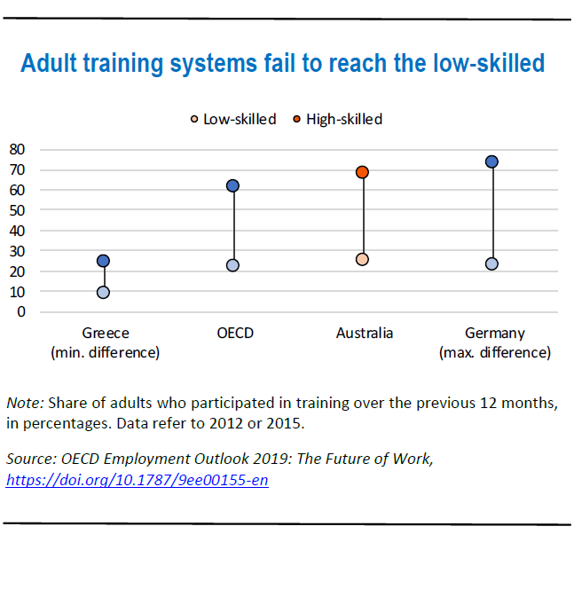
Lifelong learning, also referred to as continuous learning or adult education, has been the underpinning philosophy of the vocational education and training sector ever since the release of the Kangan Report in 1974. Kangan introduced the concept of lifelong learning as an integral element of vocational education training policy.
Students were to exercise choice by obtaining access to training programs offered by state-based systems of government-funded technical and further education institutions (TAFE). The institutions were to offer recurrent learning throughout the entire life of a student. The creation of TAFE institutes underpinned today’s VET system. TAFE institutes were the innovators and in the 1970s they developed into a world-class technical system. They were underpinned by two concepts: accessibility and lifelong learning.
Lifelong learning has many definitions. At its widest it encompasses all learning activity undertaken throughout a person’s life, with the aim of improving knowledge, skills and competencies within a personal, civic, social and/or employment-related perspective. (Commission of the European Communities 2001, Cardinal 2004). Inherent in this concept is the range of adult education - from formal education, where a learner has little control over what is taught and how it is taught, to the other extreme: self-directed learning, where a learner controls both what is taught and the means by which it is taught. (Mocha and Spear 2007.)
The following discussion focuses on lifelong learning at the formal engagement level.
Internationally, lifelong learning is seen as an important component of educational policy. It is important because accessible and fit-for-purpose education is essential to a productive country and a socially cohesive community.
For example, leaders of the Group of Twenty (G20) stressed that it was no longer sufficient to train workers to meet current specific needs. Education should ensure access to training programs that support lifelong skills development and incorporate a focus on the future needs of the labour market.
The International Labour Organization (ILO) has said that countries that have good VET systems have linked the desired gains in productivity, employment and development (i.e. industry policy) with a policy that targets the development of skills. This has three main objectives:
- to match supply to current demand for skills;
- to help workers and enterprises adjust to change;
- to build and sustain competencies for future labour market needs.
A range of international organisations have commented that for investments in training to yield maximum benefit for workers, enterprises and economies, five key components are required:
- continuous and seamless pathways of learning between the sectors of education;
- the development of core skills, including literacy, numeracy and communication skills (and these days, skills authors emphasise digital competence);
- the development of higher-level skills at the professional, technical and human resource level, enabling workers to gain access to high-quality, high-wage jobs;
- skills portability that is based around the provision of core skills, so that workers can apply their existing knowledge and experience to new occupations or industries, and a comprehensive skills assessment process that social partners accept and recognise;
- employability, which results from the integration of government policy with education.
How does Australia’s VET system compare against these components?
Seamless pathways
Pathways in VET are artificially truncated at the higher diploma level and most VET enrolments are primarily at the upper secondary level (Certificate III). Only 10 per cent of university enrolments are from the VET sector. Major barriers to access persist despite countless attempts to create pathways between VET and higher education.
Core skills
There is no evidence that we focus on the importance of core skills in literacy, numeracy or digital competence. At best, they are offered as electives.
Development of higher-level skills
Most enrolments are at entry-level (70 per cent are in Certificates I to III) rather than a higher education level. Diploma enrolments fell 18 per cent in VET in 2018.
Portability
Qualifications are not always recognised by different states, while loose assessment methods erode stakeholder confidence in the reliability of qualifications.
Employability
Employment outcomes for Certificate III graduates is high but, as is typical of a service economy, many of the jobs for graduates are highly unstable and poorly paid.
The importance of lifelong-learning strategies
- Technology replacing workers.
A consistent concern is that technology will replace workers. This has exacerbated concern over the viability of using education as a key mechanism for effective transition strategies. The evidence so far is that technological development has not been the main cause of most of the job losses. Rather, as stated earlier, technologies transform component tasks of existing jobs and drive efficiencies that allow workers to engage in more complex and abstract work.
A common view is that new jobs and continuing jobs will require a diverse mix of skills including technical skills (competencies) as well as interpersonal and digital skills. Employment is becoming more “HYBRIDISED”. Individual skill portfolios may not be achievable through a single educational qualification but could be acquired through micro-credentials, short courses and practical skills training.
If this is so, and it seems to make sense, it is incumbent upon policymakers to broaden the type of education that is made available in vocational education and training to ensure that students develop a broad range of core skills. (See Table 2.)
Table 2
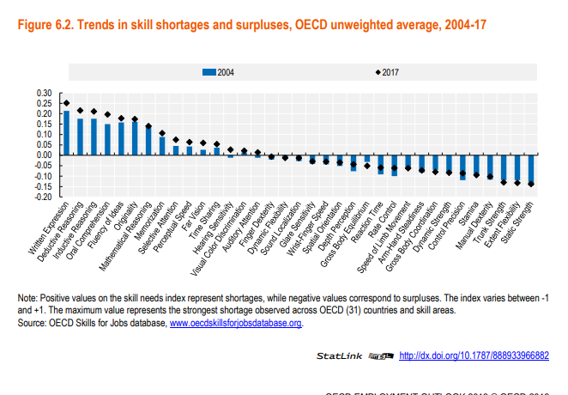
- Jobs in the service economy
One of the negative aspects of a shift towards a service economy is the increase in the number of low-skilled occupations and non-standard forms of employment. Australia’s employment patterns indicate a significantly large number of people in low-skilled jobs. (Mackenzie p 42, 2019)
The unemployment turmoil caused by the pandemic has significantly affected young people and women, in particular. This outcome is perhaps the single strongest reason why Victoria should strengthen efforts to build a strong continuing education system: to assist displaced workers and those who are most vulnerable to gain the underpinning skills required to find new employment.
Australia has very high levels of underemployment. While underemployment is not as damaging as unemployment, it does suggest that there is an imbalance between labour market needs and the skills that are emanating from both higher education and VET. (See Table 3.)

Table 3
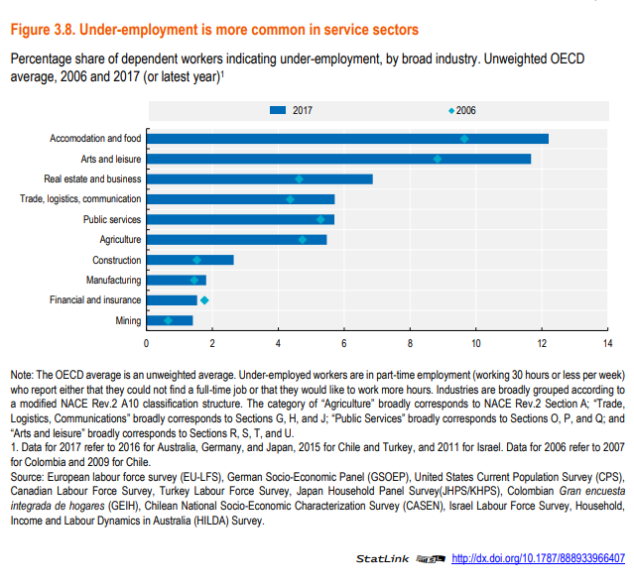
This is not surprising because Australia has a laissez-faire arrangement between higher education and labour market needs. VET is more connected to the demands of the labour market, but it does not provide students with the core skills to enable them to transfer readily to improved employment.
More sound information in regard to likely opportunities for work and earnings may assist students to make better choices and minimise underemployment and job precarity. In part, this could be linked to the Australian qualifications framework and does need to be included in schools, especially for exiting students.
Barriers to effective lifelong learning strategies (International)
A consistent theme in all the literature is that participation in training is lowest for those who need it most, including adults who only have low skills, non-standard workers and those who lose their jobs.
The barriers to people investing in gaining more skills include a lack of motivation and time, tuition fees, insufficient income support, and a lack of employer support. Training is often of a poor quality and not aligned to labour market needs. Socio-economic background, geographical distance to institutes and access to learning resources compound barriers.
A number of countries in the OECD have attempted to use individual learning accounts to try to make adult learning more accessible to a broader group of adults. These schemes generally defined the type of training that can be undertaken and target workers who have low education currently in low skilled occupations, workers employed on non-standard contracts and temporary workers. One of the difficulties of these schemes is that the more highly skilled participate far more than lower-skilled workers.
It is difficult to develop individual learning accounts and target low-skilled workers because this targeting excludes others who might benefit from such an arrangement such as the unemployed who may have higher skills.
Lifelong learning in Australia and Victoria
Australia does not have a specified lifelong learning policy. However, it does have a relatively strong record in adult participation, with 48.5 per cent of adults participating in formal or non-formal job-related learning in 2012 (above the OECD average of 40 per cent). However, this drops to 23 per cent for low skilled adults. Theoretically there are few institutional limits to access.
Strengthening adult participation and continuous learning in Victoria
Free TAFE
Both state and Commonwealth governments have developed a range of training and guidance schemes to support individuals affected by structural change.
With its free TAFE programs, Victoria has been at the forefront of reducing barriers for students so they can access vocational courses. As we have seen earlier, tuition costs can hinder adult participation in continuing education. By limiting the free tuition scheme to courses provided by TAFE institutions, the government can minimise misuse of public funds and identify those programs it believes have the greatest opportunity of providing better employment outcomes.
However, while adult students and non-traditional students can apply for higher education and are eligible for a government loan, the reality is that these students are unlikely to complete their course. In its report “The Demand driven system: A mixed report card” (2019), the Productivity Commission indicates that compared to other students, the dropout rate for non-standard students is 57 to 70 per cent higher. Regarding access to higher education, students from lower socio-economic backgrounds are still significantly under-represented.
Accessing higher education courses in TAFE institutions whose prime clientele are part-time, older students is important in an economy that is focusing on developing higher skills. Victoria could consider extending the free TAFE scheme to undergraduate programs that are available in some TAFE institutions. On the evidence provided in a Monash University study, this method leads to better outcomes for non-traditional students.
Moreover, one of the key parts of adult learning strategies is to ensure that students enter into quality programs that can improve their fortunes. Many students who have completed certificate programs enter into part-time, casualised work upon graduating. Making applied higher education accessible to these groups of students can be important, especially if it is offered flexibly.
Sound educational foundations
The curriculum used in VET in Victoria is competency-based. The design of the curriculum impedes continuing education as it does not build sound foundations for further study. It does not include core skills in literacy, numeracy and digital competence.
For students to be able to continue past upper secondary education and into higher studies they need to be competent in these core skills. The ability to continue on in education is as important as having appropriate skills for existing jobs in terms of future careers in a changing economy.
The Australian qualifications framework
The most recent iteration of the Australian qualifications framework seems to have removed the alignment to upper secondary education. It has not linked upper secondary education with Certificates I to III. This is a setback for continuous learning and a disconnect with international practice.
Moreover, it maintains the artificial distinction between vocational education and higher education. This is also a setback for the concept of tertiary education and continuous learning.
We have seen earlier that seamless pathways are generally regarded as an important part of an effective skills system. The revised qualifications framework, with four different vocational certificates and two diplomas, no alignment with upper secondary education, and a truncated VET system, is not a good example of seamlessness. Importantly, however, it does emphasise core skills and, interestingly, “ethics”.
Victoria could adopt a simpler model to clarify the outcomes of a student’s course of study. For example, it might be more helpful to designate qualifications as follows:
- foundation studies: these courses are designed primarily to develop skills for further study. Some elements could be used to develop lower order skills which may be used to gain employment, e.g. forklift driving (Certificates I and II);
- paraprofessional studies: these courses are designed to develop core skills to facilitate further study at the professional level, as well as skills for employment in a particular occupational area (Certificate III);
- professional studies: these courses are designed to provide students with core skills and enable students to access high level employment through the acquisition of Certificate IV, diplomas, undergraduate degrees and masters’ degrees.
For full time students, work placement would be an essential component of paraprofessional and professional studies.
The concept behind this type of framework is to try to emphasise to students that if they enter into a vocational qualification, it is based upon ensuring that it is relevant to the student’s long-term educational interests and/or entry into the labour market. If they choose courses that do not lead to good outcomes, they at least have the underlying skills to progress to other courses that can meet their expectations.
For-profit private providers
Enrolments in courses offered by for-profit providers today are concentrated in the same 20 training packages at the Certificate III level as was the case in 2004. In Victoria for-profit providers are located primarily in major cities and there has been a subsequent percentage decline in participation in rural areas. Rural and remote students are some of the most disadvantaged students in the tertiary sector. As Zoellner comments, the VET system delivered through the competitive training market is producing a smaller number of qualified persons in an increasingly narrow range of occupations.
The amount of money and time spent on monitoring private providers who offer a narrow range of courses, mainly at the Certificate III level with little connection to further study or continuing education, is very difficult to justify in terms of scarce financial resources.
The discussion paper comments on the complexity of the upskilling rule. This and the one-course rule were introduced because of fraud perpetrated on the system by private providers.
The benefit to the community and to continuing education of “for-profit private providers” needs to be evaluated. Any review needs to be evidence-based rather than ideologically based. Zoellner’s paper suggests that few, if any, of the claims that supported the introduction of the demand-driven system have been delivered.
Skill sets
Most people who undertake vocational education do so to improve their employment status or to get a job. Most students in vocational education are in the 25 to 44-year-old age group (40 per cent of students). Seventy per cent of all training package enrolments are in Certificates I to III, with the largest fields of study in management, society and culture and engineering.
Developing a suite of technical skill sets in conjunction with employers and TAFE and making them available through free TAFE to existing workers, especially in industries that are vulnerable, would strengthen adult participation. It is likely that existing workers in some key industries such as manufacturing have only a Certificate III. Skill sets can be offered in non-standard times i.e. weekends.
In addition, skill sets to facilitate the development of core skills, including literacy, numeracy and digital competence, for existing workers delivered in the workplace or at TAFE might stimulate a desire to attempt higher-level studies.
Conclusion
Lifelong learning is one of the underpinning philosophies behind the vocational education training system in Australia. Internationally, lifelong-learning is regarded as one of the characteristics of high-performing VET systems. Victoria has a good basis upon which to strengthen lifelong learning. Accessible, high quality, and high-skilled adult education programs are an important component of rebuilding the Victorian economy.

Bruce Mackenzie
Mackenzie Research Institute
June 2020

References

Gekara, V., Snell, D., Molla, A, & Kanasiosis, S. (2019) Skilling the Australian Workforce for the digital Economy. NCVER, Research Report.

International Training Office, (2010) A Skilled Workforce for Strong, Sustainable and Balanced Growth, A G20 training Strategy, Geneva.

Karmel, T., Australia’s approach to lifelong learning. NCVER conference paper, Adelaide (November 2014)

Mackenzie, B. (2019) Fit for purpose? Reforming tertiary education in Australia. Discussion Paper. Mackenzie Research Institute.

NCVER, Total VET students and courses, 2018, retrieved from https://www.ncver.edu.au/__data/assets/pdf_file/0031/6925090/Total-VET-students-and-courses-2018.pdf

Noonan, P., (Chair). Review of the Australian Qualifications Framework. Final report. (2019 Canberra.)

Norton, A., Cherastidtham, I., & Mackey, W. (2018). Mapping Australian higher education 2018.
Retrieved from https://grattan.edu.au/wp‐content/uploads/2018/09/907‐Mapping‐
Australian‐higher‐education‐2018.pdf

OECD (2019), Individual Learning Accounts: Panacea or Pandora's Box?, OECD Publishing, Paris, https://doi.org/10.1787/203b21a8-en

OECD Lifelong Learning for all policy directions 2001, retrieved from http://www.oecd.org/officialdocuments/publicdisplaydocumentpdf/?cote=DEELSA/ED/CERI/CD(2000)12/PART1/REV2&docLanguage=En

OECD. (2018). The future of education and skills: education 2030. Retrieved from
https://www.oecd.org/education/2030/E2030%20Position%20Paper%20(05.04.2018).pdf

OECD. (2018). Education at a Glance 2018: OECD Indicators. Retrieved from OECD iLibrary website:
https://doi.org/10.1787/eag‐2018‐en

OECD (2019), OECD Employment Outlook 2019: The Future of Work, OECD Publishing, Paris, https://doi.org/10.1787/9ee00155-en.

OECD (2019), Getting Skills Right: Future-Ready Adult Learning Systems, OECD Publishing, Paris, retrieved from http://www.oecd.org/employment/skills-and-work/adult-learning/Policy- Brief-Future-ready-adult-learning-2019-EN.pdf

Payton, A. & Knight, G. (2018) Skills for a Global future, NCVER Discussion Paper. Retrieved from: https://www.ncver.edu.au/research-and-statistics/publications/all-publications/skills-for-a-global-future.

Pennington, A., Stanford, D., Centre for FutureWork (October 2019). The Future of Work for Australian Graduates: The Changing Landscape of University-Employment Transitions in Australia

Productivity Commission. (2019). The Demand Driven System: A Mixed Report Card. Retrieved from
https://www.pc.gov.au/research/completed/university‐report‐card/university‐ reportcard.pdf.

Zoeliner, D., Student choice and lifelong learning: who you gonna call? NCVER conference paper, (Adelaide 2019)

