SKILLS FOR VICTORIA’S
GROWING ECONOMY
SUBMISSION
PART 1

Bruce Mackenzie
Mackenzie Research Institute

E: info@mri.edu.au
bruce.mackenzie45@gmail.com
M: 0417 147 016

May 2020

CONTENTS

SUBMISSION FOCUS 3
Links between productivity and tertiary education 5
Upper secondary education outcomes 7
University outcomes 9
Productivity and employment outcomes 11
Vocational education outcomes 15
Post-secondary education, productivity and economic growth 16
Transitioning Victoria’s skill base 17
Intermediate skills and the innovative productive economy 17
Strengthening intermediate skills in the Victorian economy 19
Developing a lower intermediate track in Victoria 19
Strengthening a higher intermediate track 21
CONCLUSION 24
ATTACHMENTS 26
Attachment A Current international skills position 26
Attachment B Correspondence between AQF levels and EQF levels 27
REFERENCES 28

SUBMISSION FOCUS

This submission discusses the importance of a balanced workforce in the development of innovative, productive economies and socially inclusive societies. This submission focuses on the importance of the intermediate workforce. It argues that three education sectors (upper secondary, vocational and higher education) play complementary roles in skill formation and development, whether in supporting students to enter into further education and/or gain employment.

The education systems in OECD and EU countries understand the links between each of these sectors and the fact that each sector makes an equal contribution to a productive and well-balanced society.
In contrast, Australia’s educational arrangements are out of balance. We have failed to develop a framework that is interconnected and ensures that graduates at all levels are adaptable and have both enduring core skills and workplace competencies.
It is apparent that we cannot guarantee the availability of both applied and theoretically trained graduates. Our VET system, which is so important to the development of graduates with applied skills, has been truncated by artificial sector demarcations. Our failure or unwillingness to understand the concept of complementariness has left us well behind the rest of the world in terms of skill development and an integrated tertiary system.
The key propositions of this submission are that:
- without an industry policy – and an industry policy that is integrated with educational policy – education can play only a minor role in developing a fit-for-purpose skills workforce. Furthermore, an effective industry policy has to be underpinned by implementation plans. Because Australia doesn’t have an industry policy, the focus on making higher education a way to make the economy more productive has been a failure;
- throughout the OECD and the EU, successful economies have developed diversified education systems with strong links between upper secondary education and tertiary education. They have focused equally on the intermediate skilled workforce and the higher education skilled workforce. These countries have understood the importance of an integrated skills level in the workforce and have ensured that education supports this framework;
- the curriculum used in vocational education is predicated on preparing people for specific jobs, which is not suited to a dynamic and diverse economy. Internationally, vocational education curriculum has at its core literacy, numeracy, and digital competence as well as occupationally related skills. At a time when job security is uncertain and industry generally is unsure of the impact of technological change, a broad-based curricular underpinned by core skills that can be reasonably expected to endure should underpin all levels of VET curriculum;
- successful vocational education systems have strong and direct pathways into higher education, which in turn should offer diverse routes into applied universities and research universities. Yet diversity is not a feature of Australia’s university system. Moreover, applied universities have courses that are directly linked to lower level VET qualifications. VET cannot continue to be a residual provider and focus only on entry-level qualifications. Economies that are focusing on high skills create VET systems that are relevant and offer reliable pathways to higher education.

- internationally, the intermediate skills workforce consists of two levels: lower and upper. Both are vital for initial career entry, continuing learning, career progression and a productive economy;

- an upper intermediate level workforce is vital to innovation diffusion and the successful adoption of new technologies by industry. VET has neglected this area and it is therefore in decline;
- in the OECD upper secondary education complements industry needs. This secondary education has two tracks: an academic track that streams students into universities while the professional/vocational track streams students into applied universities such as university colleges or into employment at the lower intermediate level. Victoria needs to consider restructuring its upper secondary level to make it internationally competitive;
- there is strong evidence to suggest that growth industries in Australia will require large numbers of upper intermediate personnel in the near future. A key focus in the redevelopment of Victoria’s VET system should start by reframing the paraprofessional curriculum in partnership with universities, VET institutions, government and industry;
- a diversified university system with a focus on applied learning directly linked to vocational qualifications is of great importance to the development of the workforce. Victoria should give serious consideration to the creation of a hub and spoke model for higher education. Creating two university colleges would complement existing university provision. An alternative arrangement is suggested for rural institutions.

Links between productivity and tertiary education

A central issue raised in this discussion document relates to the contribution that post-secondary education makes to productivity and occupational mobility, particularly regarding transitioning from low skilled work to intermediate skills. Since 2000, upper secondary and tertiary education in Australia has been planned around issues of productivity, transitioning from a manufacturing to a service economy, and ensuring that the appropriate skill mix, in terms of effectiveness and efficiency, were available to industry. Increasing year 12 completions and uncapping access to university education underpinned our skills formation framework.

This paper raises issues based on evidence about the effectiveness of this framework and suggests that:
- the heavy bias in public spending towards higher education at the expense of vocational education for 18 to 24-year-olds has advantaged some individuals, but it has resulted in low productivity and anaemic growth; and
- that weak government support for continuing education and training for adults over 25, compared to initial education training for new entrants into the workforce, has hindered an effective transformation of the Australian economy.
The evidence is that young people face much higher unemployment rates than older workers and that their comparative earnings have worsened over recent years. The jobs available for young people have tended to be of a lower quality. Despite many people leaving education more highly qualified than ever, unemployment for young people is around 12.5 per cent (above the OECD average, (OECD (2018)).
Australia’s tertiary education framework has evolved over three decades and was based on a set of principles/beliefs including that:
- raising the school leaving age and maintaining an academic curriculum would lead to an increase in year 12 completions and stronger demand for higher education, as well as provide non-university entrants with the skills to enter satisfying careers.
In Australia, the purpose of education is broadly described in the so-called Melbourne Declaration (Ministerial Council on Education, Employment, Training and Youth Affairs. Melbourne Declaration on Educational Goals for Young Australians (2008)), which is an agreed statement on the purpose of education. The Melbourne Declaration has two major goals (Ministerial Council on Education, Employment, Training and Youth Affairs, at p6):
- the promotion of equity and excellence; and
- that all young Australians become successful learners, confident and creative individuals, and active and informed citizens.
Two characteristics of successful learners are that:
- they have skills in literacy and numeracy and are digitally competent; and
- they have access to pathways towards continued success in further education in training or employment and can acquire the skills to make informal learning and employment decisions throughout their lives.

- by uncapping undergraduate places at universities, Australia’s economic productivity would increase;
- there was a strong unmet demand by Australian industry for graduates irrespective of discipline;
- uncapping undergraduate places would enable disadvantaged groups to enter universities and, on graduation, gain access to lucrative, prestigious and better paid employment. This, in turn, would lead to a more inclusive Australia;
The Bradley Review argued that by implementing this policy Australia would not fall behind the rest of the world in terms of the graduate supply deemed essential to the country’s productivity, it would create a more diverse student group and it would provide a stepladder of opportunity to students who had previously been denied access to higher education (Bradley et al, 2008);
- the shift to a technology infused service economy required an adaptable, flexible and innovative workforce, with graduates informed by cutting edge research who were capable of coping with the disruption associated with a changing economy and unpredictable workforce demands.
Bradley argued that the international consensus was that the reach, quality and performance of a nation’s higher education system was a key determinant of its economic and social progress. It further argued that as the world became more interconnected and the global market for skills and innovation developed further, it would be crucial for Australia to have enough highly skilled people who were able to adapt to the uncertainties of a rapidly changing future (Bradley et al, 2008);

- vocational education was important as it would provide employees with initial employment skills (competencies) that could be upgraded relatively easily on the job;
- VET graduates would be best served by being trained in competencies that made them work ready.
Schubert states that training package qualifications and competencies have become, by design, granular and narrowly defined in terms of tasks and job roles. (Schubert, 2018) The focus on narrow and very specific outcomes significantly limits workers’ ability to move between occupations and to then upskill. Yet the evidence clearly points to an increasing requirement for workers to be able to move between employers, and to take on diverse roles within their working life;

- VET would become more responsive to the educational requirements of a service economy if it were opened up to competition where nimble efficient private providers competed against the public sector;
- private providers with a focus on a sustainable profit would be responsive to employer demands while maintaining quality. The government was promoting a shift to a competitive training market to increase the effectiveness, flexibility, quality and responsiveness of VET. (Cairney, 2000)).

Upper secondary education outcomes

Year 12 completions are now at 89 per cent, with 55 per cent of completers in Victoria undertaking a bachelor degree. (The numbers destined for university has not changed significantly since 2014). For the remaining completers, VET has become less and less appealing. VET students are more likely to gain employment in low-skilled work in industries that are primarily casualised. Meanwhile, non-completers are employed in casual and low-skilled jobs in similar numbers.

Table 1 Destination patterns, Year 12 completers

Destination | 2014 | 2015 | 2016 | 2017 | 2018
Bachelor degree | 54.3% | 53.2% | 54.2% | 53.8% | 54.9%
Certificate/Diploma | 16.1% | 16.3% | 14.6% | 12.9% | 12.1%
Apprenticeship/Traineeship | 7.0% | 7.5% | 8.1% | 8.1% | 8.1%
Employed | 9.1% | 9.6% | 9.6% | 11.1% | 11.3%
Looking for work | 3.7% | 3.6% | 3.3% | 3.4% | 3.2%
Not in labour force, education or training | 0.4% | 0.5% | 0.5% | 0.6% | 0.4%

Source: On Track 2018: Destinations of Victorian School Leavers. Education and Training, Victoria State Government.
Note: To reflect diversity data applies to government schools only.

Table 2 Destination patterns, Year 12 non-completers

Destination | 2014 | 2015 | 2016 | 2017 | 2018
Bachelor degree | 0.7% | 0.9% | 0.7% | 0.8% | 0.9%
Certificate/Diploma | 28.1% | 25.8% | 23.6% | 18.9% | 19.5%
Apprenticeship/Traineeship | 25.1% | 28.2% | 29.6% | 31.6% | 32.1%
Employed | 23.9% | 23.7% | 24.0% | 25.8% | 27.5%
Looking for work | 16.9% | 15.6% | 15.9% | 16.7% | 15.0%
Not in labour force, education or training | 5.1% | 5.5% | 5.9% | 5.8% | 4.8%

Source: On Track 2018: Destinations of Victorian School Leavers. Education and Training, Victoria State Government
Note: To reflect diversity data applies to government schools only.

Table 3 Top 5 preferred employment destinations
 | 2014 | 2018
Year 12 completers | - Sales assistants and store persons (36.5%)  - Food, hospitality and tourism (28.5%)  - Labourers, factory and machine workers (6.5%)  - Clerks, receptionists and secretaries (4.1%)  - Health, fitness, hair and beauty (3.8%) | - Sales assistants and store persons (29.9%)  - Food, hospitality and tourism (29.7%)  - Labourers, factory and machine workers (8.7%)  - Teaching, childcare and library (4.4%)  - Clerks, receptionists and secretaries (4.3%)
Year 12 non-completers | - Food, hospitality and tourism (30.3%)  - Sales assistants and store persons (20.2%)  - Labourers, factory and machine workers (12.3%)  - Other (7.2%)  - Building and construction (6.6%) | - Food, hospitality and tourism (28.7%)  - Sales assistants and store persons (21.6%)  - Labourers, factory and machine workers (14.4%)  - Building and construction (8.9%)  - Gardening, farming and fishing (6.1%)

Source: On Track 2018: Destinations of Victorian School Leavers. Education and Training, Victoria State Government.
Note: To reflect diversity data applies to government schools only.

University outcomes

In Australia, 51 per cent of 25 to 34-year-olds have a tertiary degree (OECD average 44%), while 31 per cent of the adult cohort hold a bachelor degree (OECD average 24%).

ICT, engineering, manufacturing and construction are important sectors to foster innovation and economic growth. In Australia 12 per cent of adults have a degree in engineering, manufacturing and construction, but only eight per cent of tertiary students graduating in 2017 had studied in this field. It is also widely accepted that some degrees have better employment outcomes than others.

Table 4 Employment Outcomes for Graduates by Study Field, 2018
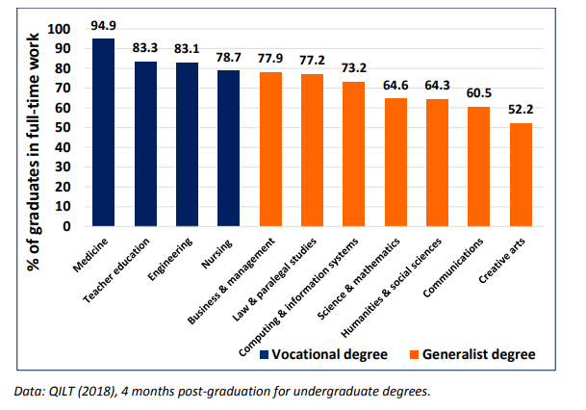Source: The Future of Work for Australian Graduates: The Changing Landscape of University-Employment Transitions in Australia October 2018
Graduates tend to be employed in the broad category of professions. It is anticipated that 107,000 new jobs will be required in the professional field to 2023.
There is increasing evidence that demand for graduates is softening and that many graduates are over-educated and over-skilled for the jobs they are performing.
In 2018, 39 per cent of all undergraduates employed (full-time and part-time) and 27 per cent of graduates in full-time work said their jobs did not allow them to fully use their skills or education. Three out of five graduates in full-time work in 2018 took a job unrelated to their study. (QILT 2018).
Table 5 Employees with Bachelor’s Degree or Above in Clerical, Sales and Labourer Occupations
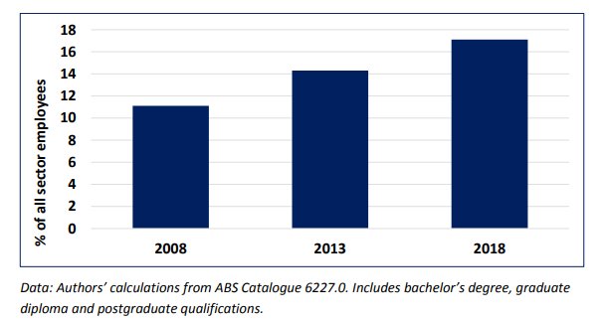
Source: The Future of Work for Australian Graduates: The Changing Landscape of University-Employment Transitions in Australia (October 2018).
There has been little to no change in the socio-economic backgrounds of students in Australian universities. Providing access on the grounds of equity, in terms of disadvantaged students, has not been a priority for universities.
Table 6 Low SES enrolment proportion by institutional groupings, 2012-2017

 | 2012 | 2013 | 2014 | 2015 | 2016 | 2017
Group of Eight | 8.8% | 9.1% | 8.9% | 8.9% | 10.0% | 9.8%
Australian Technology Network of Universities | 13.9% | 14.0% | 13.9% | 14.2% | 15.6% | 15.4%
Innovative Research Universities | 19.3% | 19.8% | 19.8% | 20.2% | 21.8% | 21.9%
Regional Universities Network | 27.6% | 27.4% | 26.8% | 26.8% | 27.5% | 27.6%
Unaligned Group | 16.7% | 16.9% | 17.0% | 17.0% | 17.5% | 17.6%

Source: Australian Government Department of Education and Training (2018). In Equity Student Participation in Australian Higher Education (p.8), National Centre for Student Equity in Higher Education (NCSEHE), Curtin University.

Productivity and employment outcomes

Australia’s productivity levels have fallen below the productivity levels of the 1980s.

Table 7 Real labour productivity growth, Australia

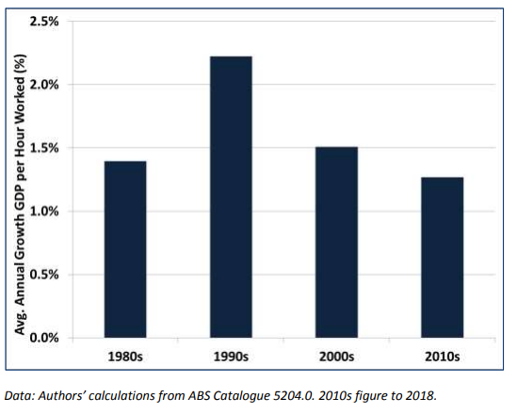
Source: The Future of Work for Australian Graduates: The Changing Landscape of University-Employment Transitions in Australia (October 2018).
Australia has the third highest level of underemployment in the OECD. Given OECD comments that underemployment in countries that were minimally affected by the recession (Global Financial Crisis) would suggest that this has been driven by persistent structural changes rather than temporary fluctuations in the business cycle. Job precariousness, casualization, a hostile industrial environment and a vague industry policy have contributed to reducing productivity.

Table 8 Percentage share of dependent workers in under-employment, 2006-2017 (or latest year)
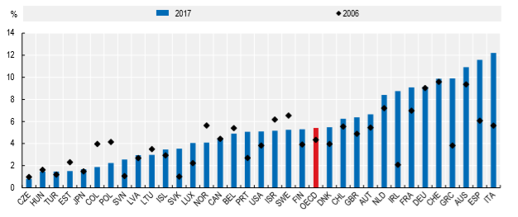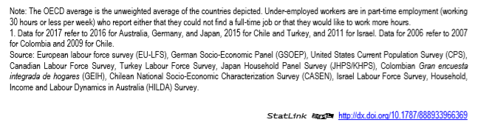
The composition of Australia’s workforce – with exceptionally high levels of graduates, a large concentration of unskilled workers, and a dearth of intermediate skilled workers – is out of balance.
Australia also has a high level of qualifications mismatch, with almost as many employees being underqualified as overqualified (Attachment A).

Table 9 Incidence of qualification mismatch in PIACC
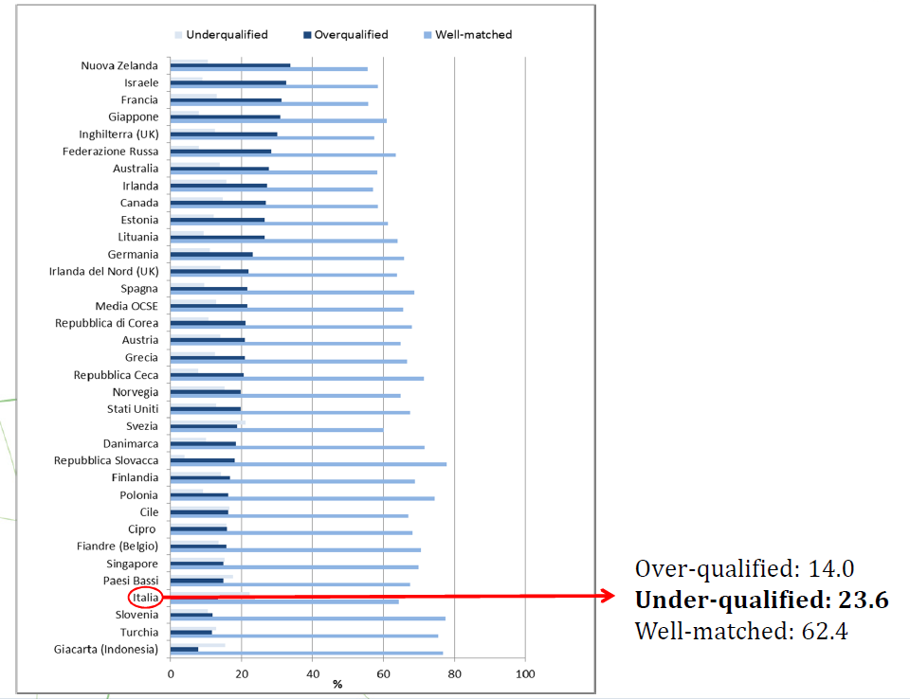
Source: B. Manuela and M. Simona, Social Integration dynamics for migrants: PIACC to measure skill and qualification mismatch INAPP Public Policy Innovation, Torina, 30 June 20, 2017
Australia has one of the highest shares of employees working in short, part-time jobs among OECD countries (13%). Moreover, 25 per cent of workers in Australia are casual employees. Young people with medium and high-level qualifications work increasingly in low-paid employment. This increase since 2006 was larger than the OECD average.
While there is high demand for both intermediate and high-skilled workers, there is no demand for low-skilled workers in Australia. Demand for high-skilled workers is below the OECD average while demand for intermediate skilled workers is above the average.

Table 10 Share of employment in high demand by skill level
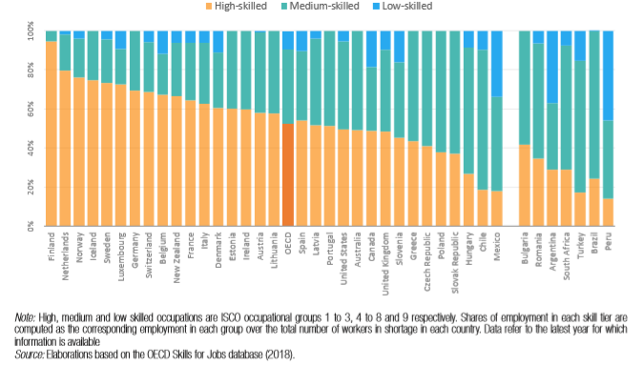
The highest jobs growth in Australia is predicted to be in intermediate/higher related skills areas, notably health, construction, education and training. Professional, scientific and technical services, primarily in software and applications programmers, are predicted to continue to grow.
Table 11 Projected Highest Job Growth Industries to 2023
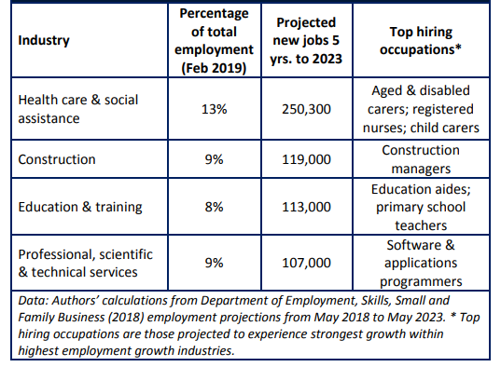

Vocational education outcomes

The impact of shifting to a service economy, combined with an inordinate focus on higher education, disastrous ideological policy constructions, fraud and confused funding arrangements, has undermined vocational education, both in terms of reputation and student demand.
We have already discussed that students exiting year 12 are turning away from VET as a preferred destination.
Since 2015, enrolments across all levels have declined, with the largest decline in diplomas and Certificate IV level. Similarly, completions at all levels have also declined.
Table 12 Enrolments in VET 2015 – 2018

Diploma and above | Decreased by 34.4%
Certificate I | Decreased by 22.7%
Certificate III | Increased by 5.99%
Certificate IV | Decreased by 18.0%

Source: ncver.edu.au/research-and-statistics/publications/all-publications/total-vet-students-and-courses-2018

Certificates I-III, which the EU and New Zealand classify as upper secondary education, account for 63 per cent of enrolments and 64 per cent of completions (NCVER, 2018). (See attachment B.) Strangely, although Victoria has destination outcomes for upper secondary academic students, whether completers or non-completers, there is no such information available for vocational students.

This lack of data is not surprising because the connection between VET and upper secondary is unclear and tenuous. Many students complete year 12 and then undertake a Certificate II in pre-apprenticeship or an apprenticeship/traineeship at the Certificate III level. This means students are going backwards educationally.
Of equal concern is that significant numbers of students undertake pre-apprenticeships in the hope of gaining an apprenticeship. (Again, no data is available on outcomes of pre-apprenticeships.) Pre-apprenticeship courses are highly specific and narrowly focused and a pre-apprentice who is unable to get an apprenticeship suffers significant educational disadvantage.
Despite a lack of support for VET and unstable policy in Australia, the OECD comments that young adults with an upper secondary qualification in Australia have good labour market prospects, with 79 per cent of 25 to 34-year-old adults employed. For those with a vocational qualification at the upper secondary level (Certificate III), the employment rate is 83 per cent (OECD average 80%). There is little difference between employment outcomes for those with a vocational upper secondary qualification or a post-secondary non-tertiary qualification.
In addition, the fastest growing occupational areas in Australia are those that are primarily related to vocational education (Table 11). As indicated earlier, there is as much demand for intermediate workers as there is for graduates.
Despite these positive outcomes and potential opportunities, participation in the vocational education system is declining significantly and suffers from a tarnished reputation (Table 12).

Post-secondary education, productivity and economic growth

It is apparent that post-secondary education, on its own, cannot boost productivity or economic growth. The strategy that Australia has adopted is to focus on a university-led post-secondary education system. This strategy was based upon a view that more graduates in the workforce would increase productivity; that is, highly educated graduates would create good jobs as supply creates its own demand.
Higher education graduates were needed because the Australian economy was transitioning to one with a need for high skills accompanied by technological change that would replace workers.
The evidence to support this assumption is thin. Moreover, the weakness of this model is that there is no clear industry strategy integrated with the education system. Australia’s university led post-secondary education system is also unaccountable in terms of its links with industry.
In addition, the industrial strategy of a high skills, technology-driven economy and the need to produce skills for the future has been supported by a series of vague statements rather than a serious plan. Hope is not a good foundation upon which to determine skills formation. Neither industry nor government has ensured the development of a high skills future.
Disappointingly, equity, which is an important component underpinning the uncapped university system, has not translated into a more diverse student population. Universities are uniformly the same in terms of courses offered and mix of students. Because the Group of Eight (Go8) has not enhanced equity targets, this means that blue-chip jobs go predominantly to the well-off and advantaged classes.
Indirectly, the status and standing of blue-chip universities and the absurd focus on research underpinning undergraduate curriculum in all universities has led to uniformity. This is apparent not only in student type but also in the curriculum on offer. Applied degrees, with a focus on industry and on non-traditional students, especially disadvantaged and adult students, are simply not part of Australia’s university landscape.
Universities in the main offer generalist degrees in a range of disciplines, hoping to become world-class (like the Go8) not by teaching effort or impact on productivity or social mobility, but in regard to their research rankings. Such rankings are a construct of universities. This focus on rankings, as much as a lack of industry policy, has contributed to a shortfall in intermediate skills in the economy.
It is interesting to note that the highly productive and socially cohesive Nordic countries have no universities in the world rankings. They also offer a diversified system - academically-oriented universities and others that have a teaching and applied orientation.

Transitioning Victoria’s skill base

So far this paper has identified that:
- there was as much demand for intermediate qualifications as there is for undergraduate skills but there is no demand for qualifications that lead to low-skilled employment;
- young people generally face a less certain future than their predecessors and that employment opportunities for low-skilled workers are increasingly marginal;
- there is significant growth in areas that are government funded and that have been primarily the domain of vocational education training.
This discussion paper identifies that a key priority for Australia and Victoria must be to reduce the numbers of low-skilled people. It can do this by facilitating a transition into intermediate employment and minimising the proportion of new entrants into low-skilled jobs. It is a socially responsible priority. A difficulty with this second point is that entry-level jobs are often low-skilled. This can trap people forever at this stage because retraining opportunities are rarely offered to the low-skilled or unemployed. In addition Australia has a significant under-employment issue.
What is less clear is the optimal split between intermediate and high skills. It is interesting to note that Germany and the Nordic countries that have highly successful economic strategies have weighted their skill mix towards the intermediate rather than the higher level. Equally, they also have a small proportion of the population holding no qualifications.
Clearly, the level of skills and qualifications has to be relevant to business and the ability of organisations to utilise them effectively. This in turn relies on an industry policy as well as the underpinning strategies to support the policy.
The trends in the Australian economy are that there is strong growth in the health and caring professions, which are primarily funded by government. This suggests that intermediate skills will become essential, especially as industries mature and regulation increases.

Intermediate skills and the innovative productive economy

Much of the commentary on intermediate skills refers to the hollowing out of the workforce, also described as the hourglass workforce, or the shrinking middle. These references relate to a decline in middle-level occupations. A closer analysis suggests that the decline is primarily occurring in areas such as manufacturing, where technology has affected supervisory jobs, and business administration.
Changing business practices affect both high-skilled and intermediate skilled work. For example, journalism: social media has seen a decline in full-time employment for the highly skilled journalist.
The intermediate workforce is a vital component in a country’s productive efforts, especially its capacity to innovate. The intermediate workforce is complementary to the efforts of highly skilled employees, such as professional engineers and scientists, who identify and acquire external knowledge that can improve production but then rely on intermediate skills to implement the theory/knowledge. The literature refers to this as the ‘adaptive capacity of organisations’.
For example, technicians undertake many key support roles in product design and development areas. One example was Holmesglen’s Furnishing Centre, which had invested heavily in high-end production equipment. Final year furniture design graduates were offered support from an industry panel comprising production technicians, who would advise on how to modify the design to make it a commercially feasible product and then produce a prototype.
Cooperative Research Centres Grants incorporate not only highly skilled researchers in a wide range of fields, but also include highly skilled technicians, especially in the building industry, to test the practicalities of some of the research solutions.
Intermediate skilled workers are a key to enabling firms that are investing in technology to be able to integrate, assimilate and exploit external knowledge. For example, in the fields of health medicine, technicians in surgery play an important role in operating enabling technology.
In a range of service industries in the aged care, health and other related services, intermediate skills are vital and will become increasingly so as standards are raised and supervision becomes increasingly important. In health care, for example, the enrolled nurse supports the registered nurse and is critical to the effective and efficient functioning of hospitals.
The intermediate skills workforce can consist of people with formal qualifications, but many will be skilled, experienced workers who can bring a product to fruition simply as a result of experience and innate knowledge. Many of these people have uncertified skills. (It is an area where, with strengthened RPL processes and external assessment, it could be of great advantage to adults and provide them with the capacity to broaden their employment opportunities.)
The literature suggests that innovative output of the workforce as a whole in the production of goods and services depends on the skills, especially intermediate skills, in turning knowledge into practice.
It has already been demonstrated that a focus on higher education as a panacea to a productive Australia has not worked. Innovation, whether in a product or a service, relies a great deal on the productive capacity of the workforce as a whole. The Commonwealth government’s innovation strategy fails to understand how innovation relies on not only higher education, but on vocational education and especially the intermediate skilled workforce. This omission is symptomatic of the understanding of VET capability in bureaucracies as much as anything else.
Throughout the OECD, courses are heavily overlaid with information technology modules in the development of technicians. These modules are designed so that intermediate skilled workers can make incremental improvements to the production process.
Mason et al (2018) claim that there is evidence that where there is a workforce of higher intermediate employees, this enables senior managers and professional staff to think strategically and perform their job well, rather than having to engage in day-to-day firefighting activities, i.e. dealing with problems that could have been avoided if the workplace as a whole had high levels of skill and competence.
In Germany, firms were found to benefit when senior managers were not required to provide detailed supervision for craft trained workers in sectors as diverse as mechanical engineering and hotels because high intermediate skilled workers were employed at the supervisory level.
A better-balanced workforce is essential if Australia is to become a more productive country. This in turn requires a significant repositioning of the status and resources available to vocational education.

Strengthening intermediate skills in the Victorian economy

In the OECD and the European Union, intermediate level skill positions are divided into two:
- lower intermediate: this refers to completing upper secondary education that prepares students for entry directly into working life and/or tertiary education; and

- upper intermediate: post-secondary non-tertiary studies that focus on practical, technical and occupational skills for the labour market. These qualifications normally take a minimum of two years full-time study at the tertiary level. They are sometimes called associate professionals or paraprofessionals and are often, but not always, undertaken by older students gaining intermediate studies on a part-time basis who gain credit for their work-related experiences.
A feature of both lower intermediate and upper immediate education is that they have strong work-based components in association with formal education.
Victoria has a partially formed upper intermediate sector, which offers diplomas and Certificate IV courses. It does not have an equivalent lower intermediate sector in upper secondary education. As such, with its vocational education organised at the upper secondary level on an ad hoc basis and offering dubious quality, Australia underperforms most OECD countries.
It is recognised that upper secondary education is outside the terms of reference of this review. However, I believe it is imperative to note the following comments from the introduction to the Firth Review: “Victorian students need access to high quality vocational and applied learning options that support them to successfully transition from school into post-secondary education and work.” (Firth, 2020)

Developing a lower intermediate track in Victoria

If the goal of vocational education is to create a system to minimise entry into low-skilled jobs for young people, then a broad-based intermediate level option has to become part of a year 11 and 12 offering. By comparing what is available internationally, it is clear that the introduction of a vocational track or professional programs for years 11 and 12 has potential.
Upper secondary education completers who do not go to university but choose VET often go backwards educationally. Certificate III, which includes apprenticeships, is regarded internationally as upper secondary. This is a clear example of why it is important to students to connect the sectors. (See Attachment B.)
Of equal concern is that there is no available information regarding outcomes for students who undertake a pre-apprenticeship and other alternative courses in upper secondary education. Such information is vital if better advice is going to be given to students regarding career choices and related educational decisions. It might also give confidence to the wider community that taxpayers’ money is being expended on useful and productive programs.
Victoria’s current vocational education arrangements are based on the assumption that people are preparing for specific jobs in primarily blue-collar jobs or low-level service jobs. VET is not seen as providing opportunities for further learning. The VET curricular does not include core skills, such as literacy, numeracy and basic digital competence, which are important not only for occupational mobility, but also for further study. Moreover, higher education is not normally available to students who undertake VET.
A vocational track in upper secondary education would focus on providing sufficiently broad and academically demanding VET programs that would allow students to gain initial employment and/or continue on to higher levels of education. A full-time, two-year vocational track, for example, would be an alternative to the existing two-year academic program. Externally assessed, this track would also incorporate significant managed work experiences, similar to that undertaken by enrolled nurses.
A number of vocations or clusters would have to be identified and then developed according to the occupation, with focused and contextually designed literacy, numeracy, communications and digital competence skills as well as relevant competencies. The United Kingdom, for example, has made significant efforts to reconceptualise upper secondary education through the development of ‘is T Levels’. The creation of higher apprenticeships has further strengthened links to higher educational and employers.
The OECD says that initial VET programs that have not been reformed provide weak links to progression to higher education. They also become unattractive to students and employers.
Furthermore, Jorgensen (2017) argues that weak opportunities for transition from apprenticeships to post-secondary education has been suggested as one cause of falling participation in youth apprenticeships.
In one of the few studies of its type, Callendar and Mason (2018) provide results derived from a 2015 survey of year 12 students in England regarding their attitudes towards apprenticeships and work. It is interesting in terms of how the opportunities for further study can influence student destinations (Table 14). Some 56 per cent of respondents were very interested or quite interested in starting an apprenticeship as long as it was likely to lead to higher education in the future. On the other hand, some 73 per cent of respondents were not at all or not very interested in an apprenticeship if this pathway were not possible.

Table 13 School and FE college student responses in 2015 to question:
After completing your studies this year, how interested would you be in these options, instead of going to university? (population-weighted)

 | Very interested | Quite interested | Not very interested | Not at all interested | Total
 | % of respondents (population-weighted) |  |  |  |  |  | n =
Start in a job even if not much formal training will be provided | 5 | 22 | 43 | 30 | 100 |  | 1396
Start in a job as long as formal training will be provided | 17 | 44 | 26 | 13 | 100 |  | 1399
Start an apprenticeship | 12 | 31 | 35 | 23 | 100 |  | 1391
Start an apprenticeship as long as it looks likely to provide an opportunity to go on to higher education later | 18 | 38 | 29 | 16 | 100 |  | 1376

Source: Further analysis of 2015 Student Survey dataset described in Callander and Mason (2018).

Creating a vocational professional track in upper secondary education in Victoria is a significant disruptor to current arrangements. Currently, however, students who do not go to university are being steered either into narrowly focused and stable jobs or being sent backwards educationally.
Victoria has been at the forefront of experimenting with broadening year 11 and 12 curricular and introducing vocational options. The outcomes appear to be less than optimal. As young people will be hardest hit by any recession, they need to be given the greatest opportunity. A high-quality vocational track has to be a better option than the current laissez-faire arrangement.
High quality vocational education has to be conducted in organisations that prioritise applied learning, offer a scale and breadth in terms of courses and students, and have strong industry links. The vocational track would be best offered in, and auspiced by, Victoria’s TAFE institutes.

Strengthening a higher intermediate track

In Victoria a type of higher intermediate track has been developed, which offers courses at the Certificate IV level. The mix of students varies from year 12 completers and non-completers to adults already in the workforce who are upgrading their skills due to shifts in their occupational responsibility.
This intermediate track is a vital component of vocational education, both in terms of its attractiveness to the workforce and to industry, and in providing a seamless pathway of learning from lower intermediate to higher level studies.
In recent years, the number of students enrolling in the higher intermediate track has declined markedly, with diplomas recording the largest fall in VET offerings (Table 12). The reasons for the decline include:
- distorted enrolment patterns caused by over enrolments related to the VET FEE-HELP scandal;
- the impact of a demand-driven system available only to universities, which led to lower entry-level requirements for undergraduate courses. Students who would normally have gone into the VET system were encouraged into the university system. This was exacerbated by a VET system that is very difficult to navigate;
- the terminal nature of diplomas, in particular in regard to the ease of access to higher education with credit caused in part by university entrance requirements, and the narrowness of a competency-based curriculum;
- an oversupply of graduates that led some to undertake employment in areas that would have once been occupied by VET graduates, especially in the fields of business, health and building and construction (site management);
- a decline of middle-level management jobs in the public sector and in manufacturing;
- an emphasis on entry-level employment, especially apprenticeships and traineeships at the expense of lifelong and continuous learning;
- an inability on the part of industry and government to understand the complementary roles of middle level personnel with higher skilled personnel, in regard to discovering innovation and its successful adaption;
- the impact of migration with 69,400 skilled and temporary skilled migrants entering Australia in 2019. (ABS, 2019). To put this number in context, there are only 60,000 apprenticeship commencements a year in Australia;
- an unanticipated slowdown in business investment and slower than expected technological impacts in the Australian economy;
- the tarnished reputation of VET.
This decline can be broadly summarised as being caused by reputational issues, competition, shifting priorities, curriculum design, underemployment, a stagnant economy and low demand.
However, the growth industries are primarily in those areas still covered by vocational education, especially health care and construction. Given that many of the jobs will require higher technical intermediate education, it is important that the VET system identifies this need, and works closely with industry and government - the principal employers in this field - to develop appropriate intermediate level programs.
In addition, much of the growth in the professional scientific and technical services is in medical-related industries, which are highly dependent on high intermediate skilled personnel working alongside professionals.
If Victorians are to benefit from a transitioning economy, at a minimum, transitional programs for vulnerable workers must be put in place. This needs to be as strong a focus as on initial vocational programs.
Just as the lower intermediate suite of programs need to be revised, so too do the upper intermediate courses need to be re-conceptualised away from a narrow, competency-based curriculum. The re-conceptualisation must emphasise broad sets of generic skills, as well as competencies in order to improve adaptability and informal continuous learning.
A broad-based curricular that develops a common core of knowledge and skills that can be reasonably expected to endure should be a fundamental principle of curriculum design, especially at a time when employment opportunities are limited, job security is uncertain and industry generally is unsure of the impact of technological change.
To strengthen the connection with higher education and to incorporate broad-based skills, some of the higher intermediate qualifications, especially those that are already two years in length, could be rebadged as associate degrees.
Kuczera and Jeon (OECD 2019) emphasise that to attract high performing students and begin repairing its status, at a time when modern economies are demanding higher-level stills, VET cannot be seen as a residual education system. Being able to offer higher level qualifications is critical to meeting the aspirational needs of young people and instilling the desire for life-long learning.
VET needs to have strong pathways into higher education and it needs to control those pathways. In the current university framework, pathways from VET are unfortunately accorded the same low status as that given to the idea of equity for students. Pathways have not and will not happen with existing universities.
Kuczera and Jeon (OECD 2019) cite Australia as an example of where students with applied or vocational backgrounds who enrolled in research universities reported a big culture shock. This reflects not only the formal work requirements, but the different cultural codes and modes of study found in higher education and vocational programs. Adult learning concepts involve very different strategies from theory-based instruction.
It should be great cause for concern that Australia is cited internationally as an example of a country whose higher education system is unable to meet the needs of a diverse student range. This suggests that changes are urgently needed.
One solution would be to create university colleges from one or two existing TAFE institutions in the metropolitan area that would act as a hub and spoke model for other public and private institutions. This would enable other institutions to offer their students seamless access not only to foundation and initial intermediate vocational programs but also to higher education.
In the regions, a federated governance model could be created in which regional colleges combine, while maintaining their own identity, to offer an expanded range of programs and services including higher education.
A revitalised TAFE sector would not only cater for the needs of adults, but also of young people in a range of areas including construction, finance, sales, information technology, tourism, healthcare, agriculture, media design, engineering and manufacturing.
In the United Kingdom specialist institutions have been created in TAFE-like institutes to develop, in conjunction with leading employers, specialisations to meet the upper intermediate technical skill needs in STEM base subjects. Institutions have also been created with employers and government to develop simulated hubs for high level skills training in strategically important growth areas. In the UK these were identified as high speed rail, nuclear, digital, creative and cultural. This is a good example of the integration of industry and education policy.

CONCLUSION

Education has the capacity to transform lives by enabling individuals to gain skills that can improve their chances. Post-secondary education, combined with an industry policy that is more than rhetoric, can supercharge an individual’s fortunes and benefit the wider community.
However, educational policy that is based upon arbitrary demarcations and has only a residual connection to the needs of the wider economy and community only benefits the few and can be a very costly and disappointing experience for many. On almost any measure, Australia’s education system has fallen behind comparative countries in the OECD.
VET is the weakest link. Marooned and unconnected to secondary education and to higher education, this arrangement is considered an anathema by all other countries in the OECD. These countries ensure that students completing upper secondary study are well equipped to choose their own destinations, whether that be into work or further study. VET students can progress without facing institutional barriers to applied higher education. The higher education framework in the OECD is diversified, offering applied universities and academically based universities. Australia does not seem to be able to grasp these fundamental premises.
At a time when there is considerable job uncertainty and job precariousness, the development of a broad-based curricular with a common core that could be expected to endure should be a fundamental principle of curriculum. Yet the VET curriculum is locked into a narrow job-focused design which hails from another age.
Educational policy, to be relevant to the wider community, needs to reflect the complementarity of skills at all levels in the productive process. This means that a well-resourced and stable policy for education will maximise student outcomes and meet community demands. It will ensure there are connections between upper secondary education and tertiary education and that those connections can be easily accessed by continuing students and those already in the workforce. The connections afford opportunity for those who learn best in applied settings as well as those who thrive in academic orientations.
Victoria has been the most innovative of all states in relation to experimenting with different choices for students in the upper secondary level. It should not be difficult for this innovative state to reshape its upper secondary framework. It will take longer but we are better positioned than any other state to diversify our university offerings. These changes will make Victoria at a minimum structurally comparative with the rest of the world.

Bruce Mackenzie
Mackenzie Research Institute
May 2020

ATTACHMENTS

Attachment A Current international skills position

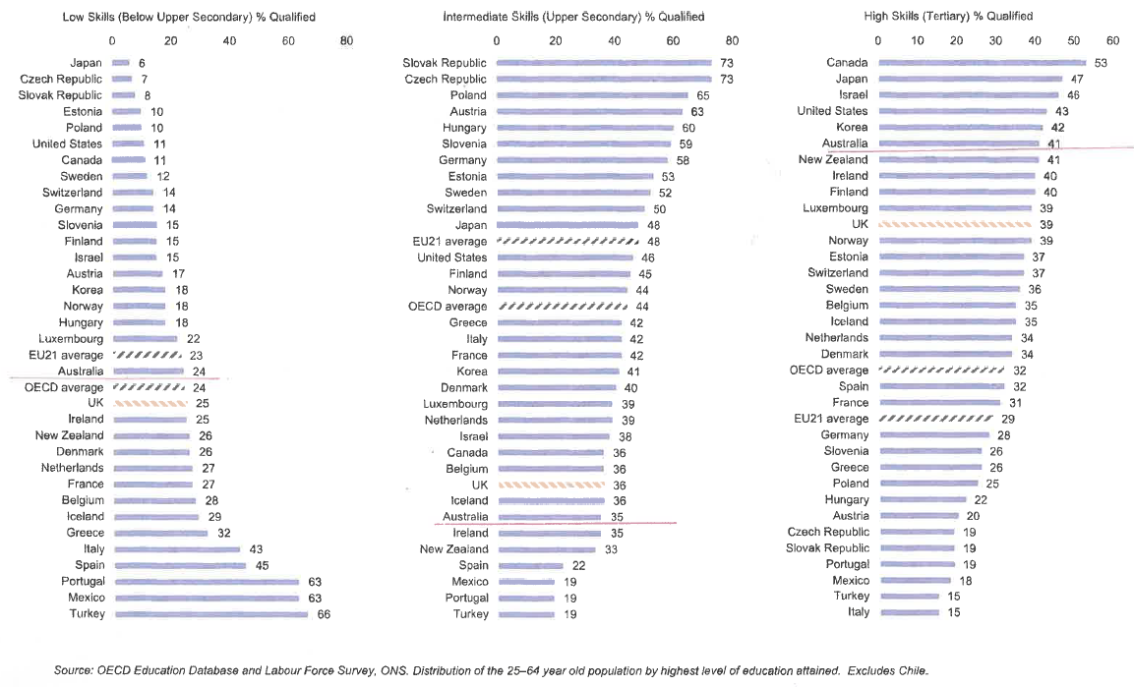

Attachment B Correspondence between AQF levels and EQF levels
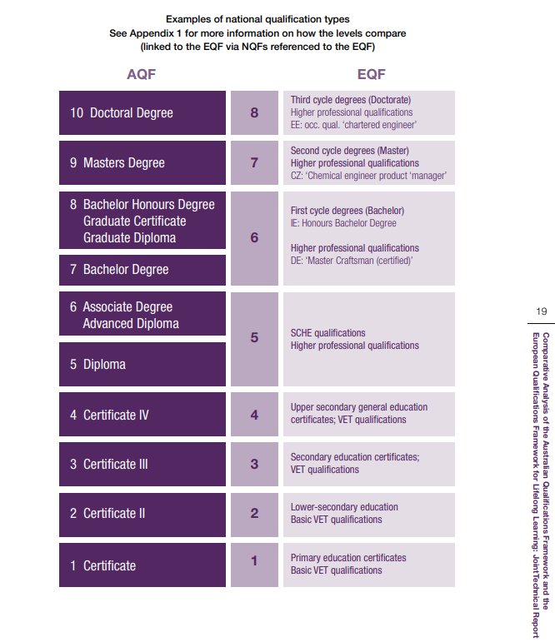
Source: Comparative analysis of the Australian Qualifications Framework and the European qualifications Framework for Lifelong Learning: Joint Technical Report 2016, Australian Government.

REFERENCES

Bradley, D., Noonan, P., Nugent, H., & Scales, B. (2008). Review of higher education: final report. Retrieved from https://vital.voced.edu.au/vital/access/services/Download/ngv:32134/SOURCE2

Dhillon, Z., Cassidy, N. (2018). Labour Market Outcomes for Younger People. Reserve Bank of Australia. Retrieved from
https://www.rba.gov.au/publications/bulleting/2018/jun/labour-market-outcomes-for-younger-people.html. 18/05/20

Jorgensen, C. (2017). From apprenticeships to higher vocational education in Denmark – building bridges while the gap is widening, Journal of Vocational Education & Training, Vol. 69/1, pp. 64-80, http://dx.doi.org/10.1080/13636820.2016.1275030

Kuczera, M. and S. Jeon (2019), Vocational Education and Training in Sweden, OECD Reviews of Vocational Education and Training, OECD Publishing, Paris. https://doi.org/10.1787/g2g9fac5-en

Mason, G. Higher Education, Initial Vocational Education and Training and Continuing Education Training: Where Should the Balance Lie? LLAKES, UCL Institute of Education, Research Paper 66. (2019)

Mason, G., O’Mahoney, M and Riley, R. What is holding back UK productivity? Lessons from decades of measurement. (2018) National Institute Economic Review No 246

OECD. (2019). Education at a Glance. Australia. Retrieved from https://www.oecd.org/education/education-at-a-glance/EAG2019_CN_AUS.pdf. 18/05/20

OECD. (2019). The Future of Work. OECD Employment Outlook 2019. Retrieved from https://www.oecd-ilibrary.org/docserver/9ee00155-en.pdf?expires=1589763723&id=id&accname=guest&checksum=A22D4B4D0F5DEB837DD850EEEFE3C8CA. 18/05/20

OECD. (2019). The Future of Work. How does AUSTRALIA compare? OECD Employment Outlook 2019. Retrieved from www.oecd.org/australia/Employment-Outlook-Australia-EN.pdf. 18/05/20

Pennington, A., Stanford, D., Centre for FutureWork (October 2019). The Future of Work for Australian Graduates: The Changing Landscape of University-Employment Transitions in Australia

Schubert, R., Goedegebuure, L. & Meek, V. L. (2018). Revisioning the System: a critical analysis and the way forward. Retrieved from https://melbourne-cshe.unimelb.edu.au/__data/assets/pdf_file/0007/2845780/Revisioning-the-system-310718-Final-004.pdf. 18/5/20

